Password for level6: aGoY4q2Dc6MgDq4oL4YtoKtyAg9PeHa1

Step 1: entering to natas 5 show the following:

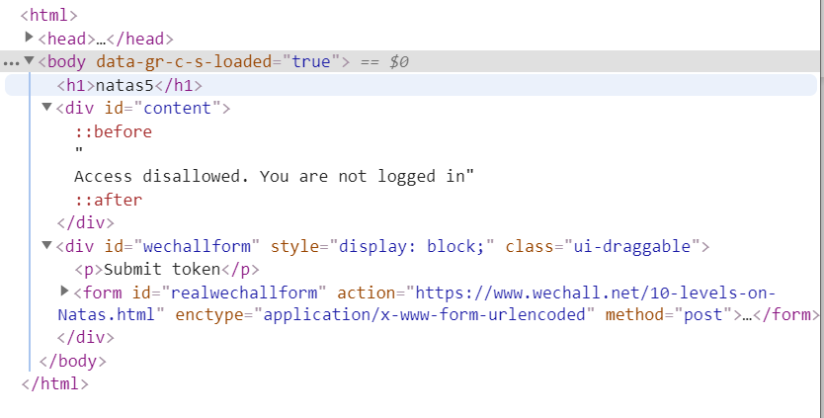Step 2: maybe the access information is in cookies.

So I created program in python called cookies.py that print the cookies data then I saw the following:

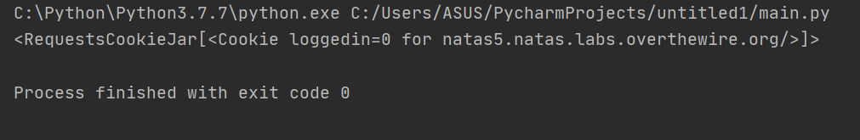

In Jason format there is cookie called loggedin with value 0

So I changed the value to 1.

And then I requests get again to see the following information in html format.

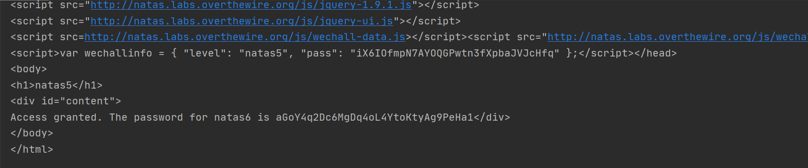

You can did it with ctrl+shift+c in chrom in application section and edit the value of 'loggedin' to 1.